User Manual

**Ralephata Innovations**

**77 Oribi Street**

**0725631020**

**011 316 3785**

**5/1/2017**

Thanyani Ralephata

This document is a user manual for the dimension calculator.This calculator is going to be useful for all employees of CTU Training Solutions for day to day operations

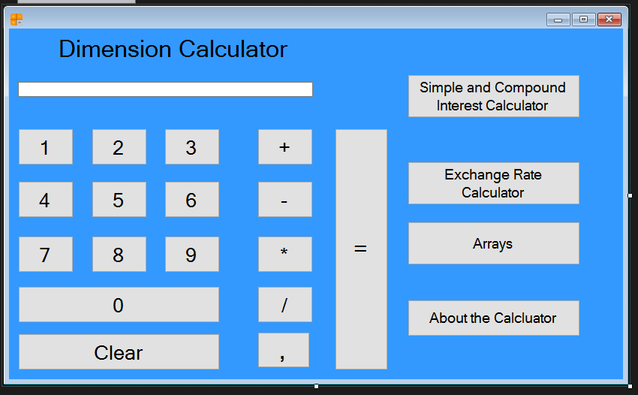Basic calculator

Figure 1.1

This is the basic calculator interface.This is where employees can make basic calcultions such as multiplying,divididing ,subtracting and adding numbers.This interface will also enable you to know about the calculator and other calculators.

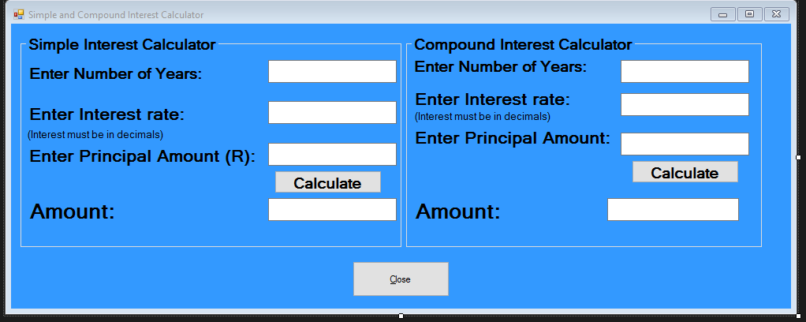Simple and compound Interest calculators

Figure 1.2

The interface above is the simple and compound interest calculators.These calculators allow the employees to calculate as to how much money or number they will accumulate after an x amount of years,interest rate and the principal amount.

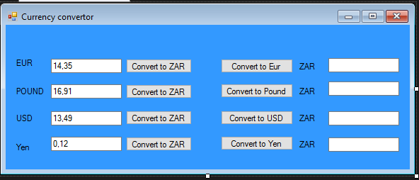Exchange rate calculator

Figure 1.3

This is the exchange rate calculator interface.This interface can be accessed by clicking on the **Exchange rate calculator** button on the **basic calculator** interface.Employees are now able to convert the Rand to other specified four foreign currencies.Employees have to type in a number and then click on the convert buttons.

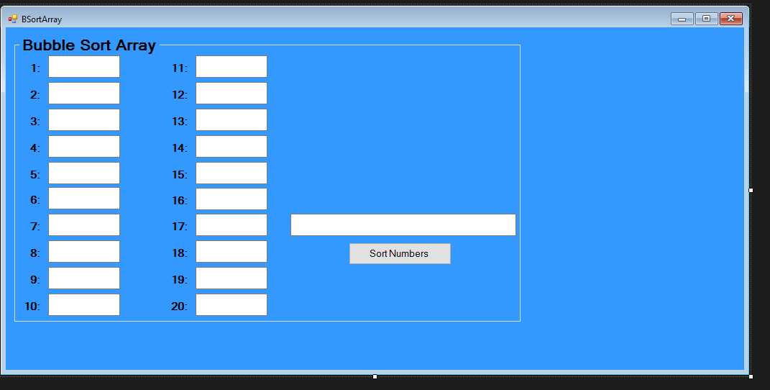Bubble Sort Array

Figure 1.4

This interface can be accessed **by clicking on the arrays button on the basic calculator’s interface.**Employees are prompted to enter **20 random numbers** and the **sort numbers** button will sort the numbers into ascending order